Math Functions

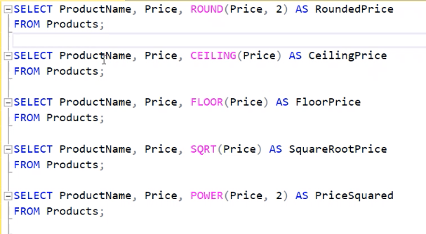

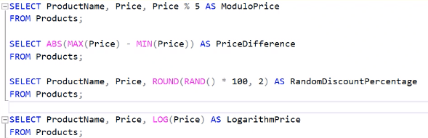

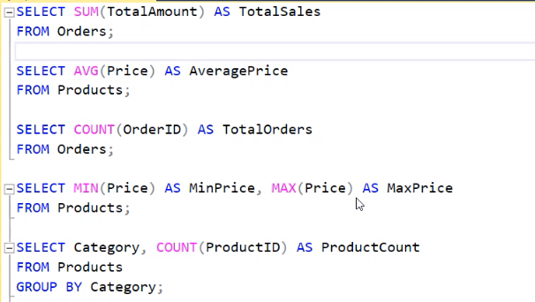

STORED PROCEDURES

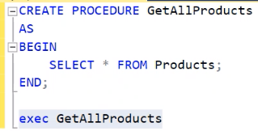

* We can store multiple queries inside the procedure
* The queries will not be seen to the outside world(provides safety)

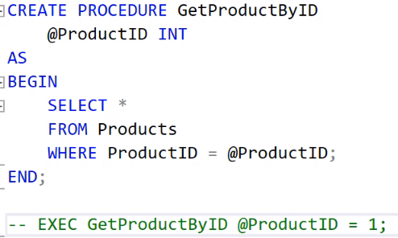

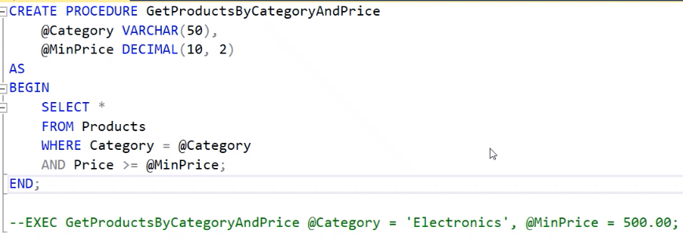

* Output Variable ^

TRANSACTION:

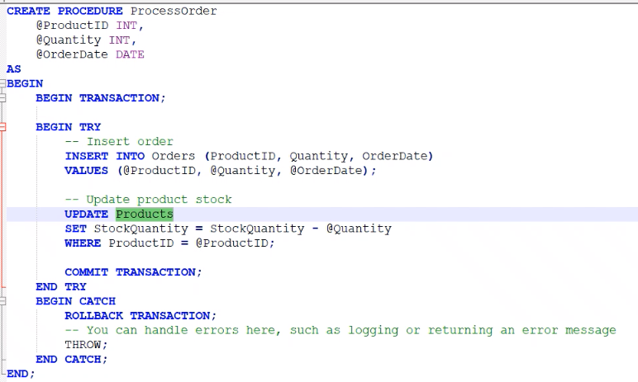

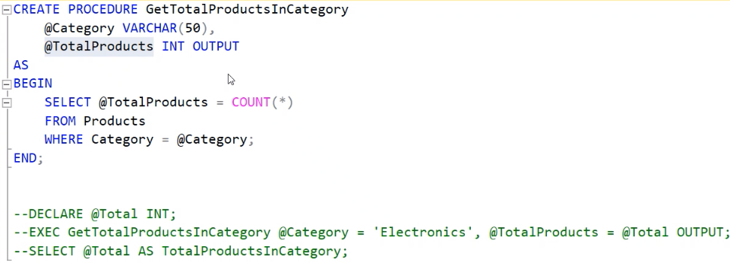

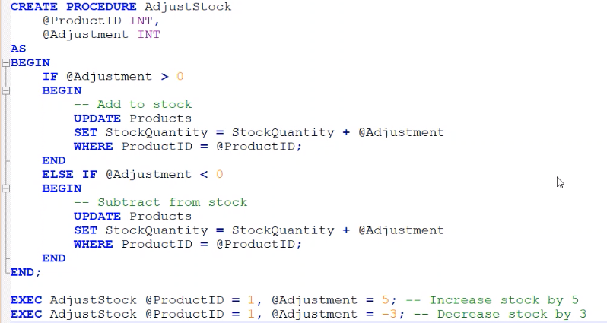

MANIPULATING DATA

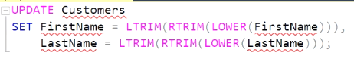

* Removing the noise and making it look alike(Unified) ^

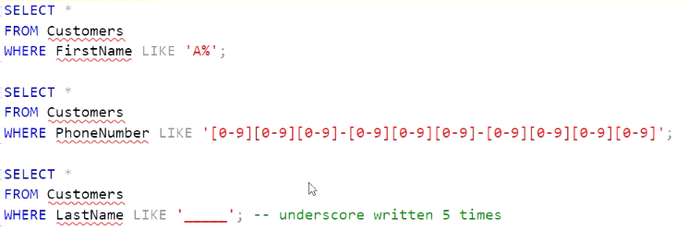

* Pattern matching ^

**PARTITIONING DATA**



* It is to visualize the data to find out the total amount spent by customer over each order

**RANKING FUNCTION**

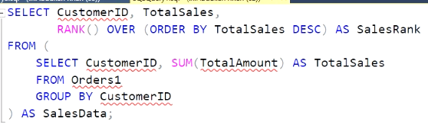

**RECURSIVE**

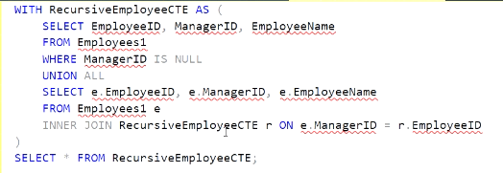

**ROLLUP**

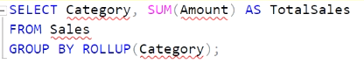

* If we use group by using category there will be some data(mischellenous data) which do not come under any category and so that data will not be shown. So we use ROLLUP to show all data.

**CORELATED SUBQUERY**

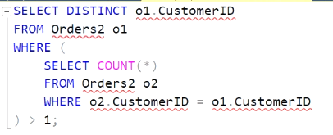

**VIEWS**

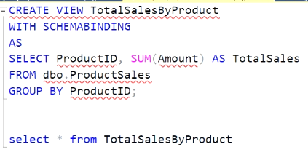

* Its like subset of the data,it will take required amount of data from table

**WINDOW FUNCTION**

* **Over (partition by )**
* First_value()
* Rank()
* Row_number()

**DATA WAREHOUSING**

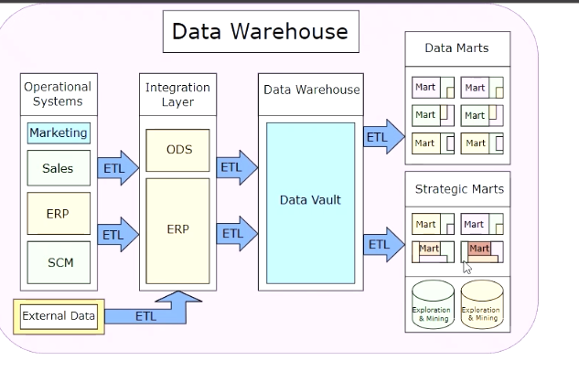

* ERP –Enterprise Resource Planning
* SCM – Supply Chain Management
* ETL – Extract Transform Load
* ODS - Operational Data Store
* Data warehouse contains whole data and data marts contains data of specified field
* Exploration & Mining -> Evolving to next state and adapting to change(RnD)
* OLTP – OnLine Transaction Processing

Workflow

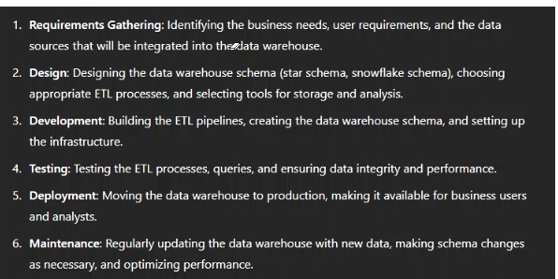

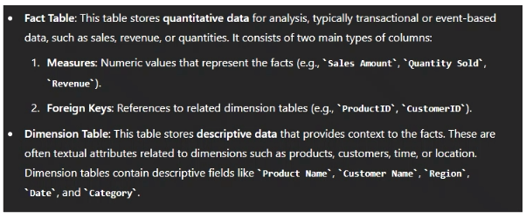

STAR SCHEMA

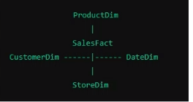

* Fact is surrounded by descriptive data ^

SNOWFLAKE SCHEMA

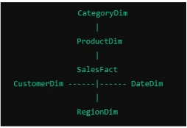

* It has more descriptive data around it